Policy Support Programme
Project ID: 00087069

Annual Progress Report
Photo credits and caption
January – December 2014

Project Snapshot

Date: |  |  | 13 Jan 2015
Award ID: |  |  | 00074907
Project ID: |  |  | 00087069
Project Title: |  |  | Policy Support Programme
Project Start Date: |  |  | 1 September 2013
Project End Date: |  |  | 31 December 2017
Implementing Partner:
Responsible Parties: |  |  | UNDP
Project Budget (all years): |  |  | 2014- $750,000
Core Resources:  Non-Core Resources:  Government contribution:  Donor 1 |  |  | $799,000
Project Brief Description and Outputs:
Policy Support Programme (PSP) operationalizes UNDP’s support to evidence based public policy formulation and advocacy as detailed in UNDP Common Country Programme Action Plan 2013-17. PSP will advocate for policy reforms for improved results based monitoring, evaluation and policy discourse through workshops, dialogues and roundtable discussions. PSP will be implemented through the Direct Implementation (DIM) modality of UNDP.
PSP is an implementation arm of established Development Policy Unit at UNDP Pakistan. PSP has four main outputs:
1) Exchange of learning and solutions on selected themes promoted: Under this output, PSP will facilitate the exchange of knowledge and experiences on key development issues. This will include the establishment of at least two communities of practice on selected themes.
2) Research undertaken and knowledge generated: The project will support research on selected themes and produce knowledge products including policy papers on inequality, report on Multi-dimensional Poverty Indices etc.
3) Cross practice project development support: This would include support for the preparation of a long term project with the Planning Commission of Pakistan in support for the implementation of Vision 2025 and implementation of MDG Acceleration Framework.
4) Supporting advocacy around MDGs and poverty:
Overall Project Quality Rating (mark on the scale of 1 to 5 as per the following criteria):
Exemplary (5)  ***** | High (4)  **** |  |  | Satisfactory (3)  *** | Poor (2)  ** | Inadequate (1)  *
All outputs are rated High or Exemplary | All outputs are rated Satisfactory or higher, and at least two criteria are rated High or Exemplary |  |  | One output may be rated Poor, and all other criteria are rated Satisfactory or higher | Two outputs are rated Poor, and all other criteria are rated Satisfactory or higher | One output is rated Inadequate, or more than two criteria are rated Poor
Budget 2014 |  | $750,000
Expenditure 2014 |  | $ 750,000
Delivery % |  | 100%
Contents

- Introduction

- Situation Analysis
- Project Performance and Results
  - Contribution toward Country Programme Outcome
  - Achievement of Project Results/Outputs

- Lessons Learnt

- The Way Ahead/Key Priorities for 2015

Annex 1: AWP Based reporting matrix
Annex 2: Annual Project Quality Assurance Assessment

Acronyms

CPAP Country Programme Action Plan
DPU Development Policy Unit
EAD Economic Affairs Division
EFA Education for All
GoPb Government of Punjab
MAF MDG Acceleration Framework
MDG Millennium Development Goal
NGO non-government organization
NPA National Plan of Action
PRSP Poverty Reduction Strategy Paper
PSP Policy Support Programme
PEPGI Promoting Employment and Productivity in Garment Industry
TVE Technical and Vocational Education
USAID United States Aid

- Introduction

The project OP/Country Programme Outcome under which PSP operates is - creation of employment opportunities and decent work through industry, construction, services, vocational/skills training, agricultural and cultural development, as well as promoting youth employment and public-private partnerships. The expected output CPAP is 2.1.1, which states: Planning and finance institutions and women’s departments at federal and provincial levels are enabled to develop comprehensive development strategies, with a focus on MDGs acceleration, inclusive growth, gender equality and women’s empowerment.

Policy Support Programme (PSP) is an implementation arm of Development Policy Unit. The implementing partner is UNDP itself as this is a DIM project. However at time of inception the responsible parties included: UNDP, Planning and Development Departments and Planning Commission. The project started in 2013 with an end of project date of 2017.

- SITUATION ANALYSIS

The government machineries at the federal and provincial levels also played a positive role for progress towards the outcome. The senior government officials in the Planning Commission including the Federal Minister led most the initiatives from the front and provided the required institutional support. The strategic partnerships with key institutions created the necessary buy-in for policy advice and support by UNDP.

Internally within UNDP, the articulation of a clear theory of change and the needed action plan helped in making concrete progress towards the achievement of outcome. The ability of the staff to quickly grab the opportunity when offered set the foundation for continued partnerships. For example, when the Planning Commission requested for short term technical support to its process of preparation of Pakistan Vision 2025, UNDP immediately provided the same. It not only provided an entry for UNDP to provide long term policy support to the government but also earned government’s trust in UNDP as an efficient institution to partner with.

Data and evidence help in advocating for change. The MDG Report 2013 provided data and timely analysis on the status of different development indicators / MDGs and was thus instrumental in mobilizing government attention and efforts to make efforts towards the achievement of MDGs in Pakistan. The adoption of the process of MDG Acceleration Framework was also a product of the advocacy and evidence that the MDG report 2013 had generated.

Project Performance and results

  - Contribution towards Country Programme Outcome
CPAP Outcome:
Creation of employment opportunities and decent work through industry, construction, services, vocational/skills training, agricultural and cultural development, as well as promoting youth employment and public-private partnerships

Indicator(s):  Indicator: Number of evidence-based policies and strategies formulated and implementation  supported with federal and provincial governments; | Baseline:  Government’s Economic Growth  Framework highlights policy and capacity gaps that limit the achievement of inclusive growth and  MDGs | Target(s):  Target 2013: Balochistan Comprehensive development strategy developed; MDG acceleration  framework developed in Punjab, KP and Balochistan; Inclusive Growth Centre operationalized;  Sindh MDG report finalized and launched; Post 2015 Development agenda Key Messages  Report  Target 2014: Provincial growth strategies developed for each province; result-based  management introduced in the Planning Commission and other line departments | Achievement(s):  - Millennium Development Goals Acceleration Framework (MAF) Report,  - Consultations towards development of Multidimensional Poverty Index (MPI) in Pakistan,  - Four issues of Development Advocate Pakistan (DAP)magazines launched with policy discussions on Local Governance, Education, Political Economy of budget and Elections Reforms,
Description of output level high/outcome level results achieved in 2014:

- Poverty measurement has been a thorny issue in Pakistan. Besides criticism on its methodology and accuracy, the use of the currently used unidimensional poverty measurement approach is not much useful in informing public policy and resource allocation discourse. With UNDP’s advocacy and technical support, the Planning Commission of Pakistan undertook the policy decision to test and adopt the Multi-dimensional Poverty Index (MPI) as an official poverty measure to guide poverty programmes and resource allocations. A national consultation process ensued to gather inputs and feedback from policy makers, technical experts and thought leaders to design national and sub-national MPIs. A tripartite agreement between the Planning Commission, UNDP and Oxford Poverty and Human development Initiative (OPHI) was signed for technical cooperation and exchange of knowledge and best practices.

With national and sub-national MPIs to be finalized in 2015, this policy support lays the foundation for a transformational change where the government’s policies would be informed by priorities for poverty targeting and human development. The MPI has already been incorporated in the Pakistan Vision 2025 as a baseline to measure government performance. The adoption of MPI will be the major policy shift in Pakistan since its independence with regard to poverty measurement.

- Pakistan adopted MDG Acceleration Framework (MAF) for education: Pakistan has the second largest number of out of school children in the world. With UNDP’s support, Pakistan for the first time adopted the MAF approach for increasing enrolments and quality of primary education. The MAF was also presented to the UN Chief Executive Board (CEB) meeting in November 2014 chaired by the UN Secretary General. The MAF process not only brought together the federal and provincial governments, but was instrumental in synergizing the efforts of UN agencies and the World Bank for coordinated support towards universal primary education in Pakistan.

- In support to the UN process of developing the new development agenda post 2015, UNDP, on behalf of the UN Coordinator, successfully led the second round consultations that gathered feedback from diverse stakeholders on role and importance of “capacities and institutions” for the achievement of Sustainable Development Goals. More than 2,000 people including policy makers, marginalized communities and civil society were consulted and report submitted to the UN focal persons.

- UNDP continues to remain the main development partner of the Planning Commission of Pakistan. UNDP provided support in the development of Pakistan Vision 2025 and conducting national consultation process on governance reforms in Pakistan. UNDP and the Planning Commission principally agreed to launch a $ 14 million project for reforms in public sector with Government of Pakistan committing $ 7 million.

- Pakistan’s youth population stands at around 30 percent of the total. Youth is an unexplored national asset of the country. To transform this asset into youth dividend, UNDP initiated the process of National Human Development Report on youth. With the Federal Minister for planning being the chair of the NHDR advisory council, the report is expected to influence and inform the national youth policies.

- During 2014, UNDP repositioned itself to play a more active role in policy debate and development policy. It launched a quarterly policy publication, “Development Advocate Pakistan” which provided analysis and opinions on key development challenges in the country including local governance, electoral reforms, education and the political economy of the budget.
Means of Verification

Progress towards Project Results/Outputs
Project Output I: Exchange of learning and solutions on selected themes promoted
Indicator(s):  - Number of Communities of Practice (CoP)on selected themes established and extent to which CoPs have been made effective  - Extent to which best practices related to human development effectively informed policies / interventions in Pakistan |  | Baseline:  - No significant existence of online community of practice in Pakistan  - No systematic and focused initiatives for south-south learning influencing national policies |  | Target(s):  - 2 on line communities of practice revived/established  - At least two policy papers  - At least one international / regional best practice on poverty reduction or social protection or MDGs shared with partners in Pakistan  - At least on national workshop / social good summit  - One regional workshop on evaluation |  | Achievement(s):  - 06 Themes finalized for offline communities of Practice  - Policy paper on “Political economy of the budget in Pakistan: Pitfalls and opportunities for the reforms” prepared.  - National capacities strengthen for effective and high quality evaluations through exchange of knowledge and experiences at International conclave on  National Evaluation Capacity Development held.
Description of output level results achieved in 2014:

Established communities of practice on selected themes; six areas finalized for establishing offline Community of Practice (by setting up advisory committees) on inclusive human development, Disaster risk management, Electoral reforms, Youth and violence reduction. Each COP will comprise of thought leaders and experts in the areas of poverty reduction, inclusion, employment, social protection etc. from the government and outside led by a senior advisor. The objective of COP is to have informed discussion on key development challenges related to poverty, disaster management and other issues concerning human development. The COP/ committee will also recommend reviews/ studies and policy papers on related issues. The main recommendations will help inform UNDP’s and Government’s projects related to human development.

UNDP in partnership with Social Policy and Development Centre prepared a policy paper on “Political economy of the budget in Pakistan: Pitfalls and opportunities for the reforms”. The research analyzed the various aspects of budget formulation and implementation in the context of political economy. It reviewed recourse mobilization, public expenditures priorities and quantum and financing of fiscal deficit by translating their technical aspects in a reader friendly manner. It paper will help in facilitating institutional accountability and transparency of budget.

South-south learning/ Triangular partnerships:

A MOU was signed between Ministry of Planning Development and Reforms (MOPDR), UNDP & OPHI for technical cooperation and learning from other countries on the use of MPI as public policy tool for poverty measurement & targeting. Through this MOU, the MOPDR became member of high-level Multidimensional Poverty Peer Network. Platform will facilitate sharing of experiences among policymakers from different countries that are exploring & using MPI as an official instrument for poverty measurement

- Policy advocacy and knowledge building for Government counterparts promoted through South exchange of learning. Two main activities undertaken included:

i) UNDP supported Government participation in High-level Meeting of the Multidimensional Poverty Peer Network held on 7-8 July 2014, Berlin, Germany. The forum provided opportunity to Government of Pakistan to learn from other countries experiences and issued related to use of MPI as methodology for calculating poverty for informed policy and decision making.

ii) Participation of the parliamentarian/ policy makers from government of Pakistan supported for panel discussion on Accelerating Progress, Sustaining Results, and Transitioning from the MDGs to the SDGs at the 2014 High level political Discussion on Sustainable Development held in New York in July 2014. The representation at the forum provided an opportunity for Pakistan to share its lessons learned from MDG implementation to accelerate and policy measures and be part of the intergovernmental discussion on the post 2015 development agenda and creating important for creating ownership in leading the consultation happening at the national level.

International conclave on National Evaluation Capacity Development (NECD) was held on March 12, 2014 jointly organized by the Ministry of Planning, Development and Reform, Government of Pakistan and UNICEF, UNDP and UN Women.

NECD conclave aimed to develop and strengthen national capacities for effective and high quality evaluations through exchange of knowledge and experiences on the benefits and value addition of evaluations in public and non-public sectors. The conclave provided a platform for South-South exchange to enhance learning about successful strategies, lessons learnt, and challenges with regard to developing national capacities for evaluations in Pakistan. The workshop brought together evaluation experts and practitioners from the government, United Nations and the civil society from Pakistan, South Asia and beyond.

The dialogue emphasized on having a strong country monitoring and evaluation system that strengthens implementation is crucial to not only ensuring that such policies are being implemented in the most effective and efficient manner; but that policy implementation and design is reviewed regularly to detect bottlenecks and to inform on adjustments needed to enhance systemic capacities to deliver results.
Overall Output Status (mark the output on the scale of 1 to 5 as per the following criteria):
Exemplary (5)  ***** | High (4)  **** |  | Satisfactory (3)  *** |  | Poor (2)  ** |  | Inadequate (1)  *
The project is expected to over-achieve targeted outputs and/or expected levels of quality, and there is evidence that outputs are contributing to targeted outcomes | The project is expected to over-achieve targeted outputs and/or expected levels of quality |  | The project is expected to achieve targeted outputs with expected levels of quality |  | The project is expected to partially achieve targeted outputs, with less than expected levels of quality |  | Project outputs will likely not be achieved and/or are not likely to be effective in supporting the achievement of targeted outcomes
Means of Verification
- Feedback from senior management of Planning Commission regarding one day traini9ing on Key Performance Indicators.
- Agreement by Planning Commission regarding MPI, MoU and participation in OPHI Multidimensional Poverty Peer Network (MPPN).

Project Output II: Research undertaken and knowledge generated /disseminated on selected development theme
Indicator(s):  - Number of policy papers on MDGs based on research / evidence based analysis  - National Human Development Report (NHDR)  - Number of district level MDG localization plans  - Number of workshops |  | Baseline:  - Lack of reporting on assessments and robust research undertaken specially on MDGs. The latest National Human Development Report was compiled and published in 2002.  - Limited knowledge and information on localization of MDGs at District level |  | Target(s):  - At least four research studies (including one study on horizontal inequality in Pakistan) designed and conducted resulting in four (or more?) Policy papers (including one on the issues and constraints affecting institutional effectiveness) on selected MDGs.  - Updated and regionally comparable multi-dimensional poverty figures available  - At least four district level localization plans available  - Online dashboard on MDGs refined and expanded |  | Achievement(s):
Description of output level results achieved in 2014:

The concept note on FATA Reforms developed after having discussions with a wide array of informed people—politicians, government officials, civil society, academia, development partners—who have worked in the region or been previously engaged in FATA reforms over the last decade. The note has also benefited from a desk review of available reports, literature on FATA and a detailed mapping of reform initiatives undertaken so far and an assessment of their status and impact over the last decade

This concept note outlines an initial course of action to support Federally Administered Tribal Areas (FATA) reforms so they may be sustained and institutionalized and is based on the premise that while reforms in FATA are urgently needed, these couldn’t produce sustainable results unless the people of FATA participate in the reforms’ process and they own it.
A full scale proposals/project, focusing on thematic areas such as youth entrepreneurship, rule of law, peace and social cohesion etc. will be developed as part of this concept note and after discussion and agreements with government and development partners.

National Human Development Report 2015 on “Youth”: Pakistan’s youth population stands at around 30 percent of the total. Youth is an unexplored national asset of the country. To transform this asset into youth dividend, UNDP initiated the process of National Human Development Report on youth. With the Federal Minister for planning being the chair of the NHDR advisory council, the report is expected to influence and inform the national youth policies.

A high level Advisory Council is established and functional. The committee met twice this year; mid-August and mid December 2014. In the first meeting the team gathered gathering valuable input and guidance from the council members. The NHDR team subsequently invited an additional member to the Council to ensure greater political representation.

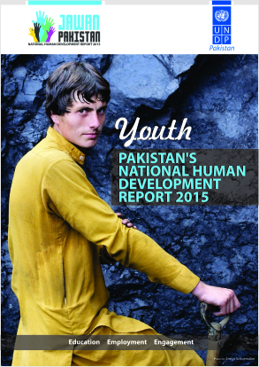
Most of the NHDR activities last six months have focused on establishing the management and writing team; initiating consultation activities; preparing for the research stage of the project, and developing communications tools. With respect to consultation and research activities, four scoping consultation events have taken place over the course of September, spanning locations at Bytes4All, LUMS (Lahore School of Management Sciences), IDEAS (Institute for Development and Economic Alternatives) and NUST, Islamabad. Meanwhile, the NHDR team has reached out to partners in civil society and the donor community for support for future engagement events over the next quarter. In tandem, TORs were developed for the survey firm for the youth perception survey and initial working sessions were held between the Lead Author Dr Faisal Bari, Statistician and Lead Coordinator to agree on approaches to the survey work and statistical annex to the report.

The final area of activity has been around communications. The NHDR team hired a web-designer to develop an NHDR-specific website, and launched accounts on Twitter and Facebook. Further, the team has developed a ‘youth directory’ - a compendium of youth groups in Pakistan (spanning sports, politics, religion, community associations and other interest groups) to reach out to, to ensure that the team receives a diverse set of views and opinions.

Over the last quarter of 2014, the NHDR consultation activities have expanded significantly. In November, the NHDR team conducted week-long youth consultations in Central Punjab, spanning diverse cohorts such as rural youth, factory workers, transgendered youth, madrassah students, young female sex workers and university students across Sheikhupura, Faisalabad, Jhang and Sargodha. Later in December, the team extended these engagements to KPK speaking to the young Hindu community, youth entrepreneurs, secondary school students, youth volunteers, young coal miners, the young Kalash community and a range of students across Peshawar, Charsadda, Swat and Chitral. These interactions have provided depth and breadth to our understanding of youth’s hopes and fears in Pakistan today.

Further, the NHDR team conducted a National Experts Consultation in Islamabad in December based on the think piece papers received from the NHDR’s Contributing Authors. This included presentations from thought-leaders such as Moeed Yusuf, Ali Cheema, Mosharraf Zaidi and Raza Rumi (remotely), and allowed for more complex themes related to youth to be explored by a number of experts present at the event. In addition, the NHDR team held the second Advisory Council meeting in Islamabad in December, allowing for a review of progress to date and advice for upcoming activities on the project.

In relation to the survey, the survey firm has been selected with a contract signed and a final version of the questionnaire prepared. Fieldwork is now set to begin in January. In the meantime, the NHDR team has developed an approach to the Youth Development Index and sub-national Human Development Indices for Pakistan, based on the advice from a colloquium of statisticians and demographers held in November.

Finally, on communications, a media firm was selected to manage a range of media and communications activity for the team including videoing the youth consultation activities and advertising the Youth Hopes and Fears art competition. The NHDR team has since received 61 submissions to the art competition with judging planned for January 2015.

Online dashboard on MDGs/ SDGs developed on the status of MDGs at the sub national level (districts) using DevInfo database technology. This will enable the users to generate interactive map on district wise status of MDGs with an option to download the data in excel or work format in a standard template as well as to generate different graphs.

MDGs localization at the district level: The MAF action plans summarize interventions that could accelerate progress towards UPE, identify bottlenecks to implement the identified interventions and then propose solution to address the bottlenecks. Of the many challenges, one has been related to the availability of region / district data on the causes of low enrolment and poor quality of education and lack of inter sectoral / departmental coordination. But besides the monumental challenge of out of school children at the national level, there are inequalities in education outcomes across different provinces, regions and districts. Some districts have comparatively higher enrolment rates than that of other districts. Putting these together, issues related to the governance of education were pointed out to be stumbling blocks to UPE.

A study has been commissioned a study targeting district Narowal, as one of the performing district in Punjab, to identify the key enablers for high enrolment / quality of primary education, and the challenges and governance issues in sustaining higher enrolment related to education could be addressed through an effective and efficient public administration and inter sectoral coordination.

National dialogue on Post 2015 Development Agenda: UNDP, on behalf of the UN Resident Coordinator in Pakistan, led the 2014 second round of consultations on the post 2015 development agenda focusing on “Strengthening Capacities and Institutions” as the ‘means of implementation’ (MoI). The stakeholders of the entire process included federal and provincial governments, civil society, academia, UN, bi-lateral and multi-lateral donors, youth, women and vulnerable groups engaged through Online survey, community based focus group discussions and a National consultation meeting.
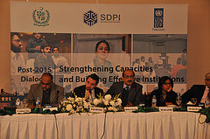
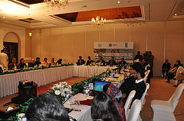

The Dialogue emphasized the need of responsive and accountable institutions and greater capacities of governments to effectively implement the new inter-dependent, transformative and universally applicable development goals.

Some of the key findings of the national dialogue include:

- Strategic planning, monitoring and reporting are of extreme importance. Planning should be done by establishing short and medium term goals rather than only having end-point targets. The government needs to become much more innovative using research and analyses across different countries to build their capacities in foresight and strategic planning.

- Localization of SDGs to local context is also one of the priority areas of the post 2015 discussions. In Pakistan, such localization efforts should go beyond the national level. In the post 18th Constitutional Amendment situation, localization has become the most critical element of an effective implementation mechanism for SDGs. In the current devolved governance structure, Pakistan would need to develop coordination mechanisms through which national and provincial plans and actions could be synthesized and experience and best practices shared.

- The Government should put in place a robust “results framework” informed by specific, measurable, achievable, realistic and time bound “key performance indicators – KPIs. To the extent possible, such mechanisms should be established at the lowest administrative tier to measure not only the success of public policy but also to provide foundation for a system of accountability and performance management of different actors and institutions.

- Statistical capacity is the key to planning for and tracking of SDGs. National capacities on data and statistics need to be strengthened. Survey tools and procedures to collect data on key variables should be aligned at federal, provincial and regional statistic departments. Investment in statistical machineries to collect and make available timely data on the status of MDGs/ SDGs should be given priority.

- The civil service and public administration should be aligned to the realities of 21st century. Without an efficient public service, Pakistan wouldn’t make substantive progress towards SDGs. It therefore needs to reform its public administration from an authoritarian to a service oriented organization.

- Citizens should be made aware of their rights. There is a strong need to raise awareness among the citizens to exercise the right for creating demand for delivery of efficient public service as well as to hold the public offices accountable.

- More emphasis should be given to local resource mobilization. Post 2015 development agenda will be different from the era when the MDGs were designed because of the context. SDGs are being formulated in a situation when the world economy is recovering from the financial crisis and hence there is less fiscal space available with the developed world to support the developing countries. The developing countries would therefore need to explore their own resources to fund their development ventures and achieve SDGs.
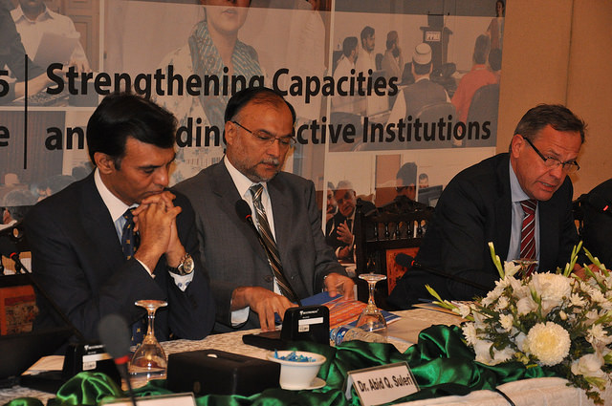
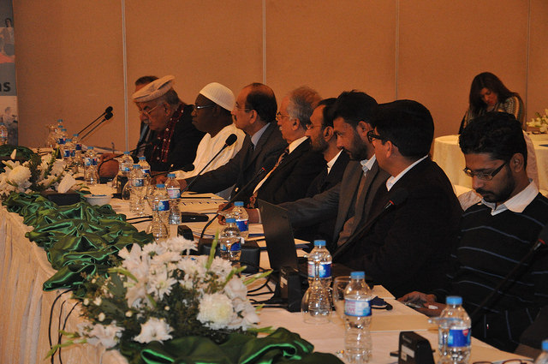

Overall Output Status (mark the output on the scale of 1 to 5 as per the following criteria):
Exemplary (5)  ***** | High (4)  **** |  | Satisfactory (3)  *** |  | Poor (2)  ** |  | Inadequate (1)  *
The project is expected to over-achieve targeted outputs and/or expected levels of quality, and there is evidence that outputs are contributing to targeted outcomes | The project is expected to over-achieve targeted outputs and/or expected levels of quality |  | The project is expected to achieve targeted outputs with expected levels of quality |  | The project is expected to partially achieve targeted outputs, with less than expected levels of quality |  | Project outputs will likely not be achieved and/or are not likely to be effective in supporting the achievement of targeted outcomes
Means of Verification
- Recruitment almost completed.
- MDG one pagers prepared for Punjab and Sindh.
- Minutes of Advisory Council.
- Input from authors (lead and contributing)

Project Output III: Advocacy undertaken to influence government resource allocation policies and poverty measurement methodologies.
Indicator(s):  - Establishing Multi-dimensional Poverty Indexes (MPIs) at the district level  - Extent to which Development Advocate Pakistan / Multi-dimensional Poverty Index (or any other magazine) effectively influence government resource allocation policies |  | Baseline:  Limited information / analysis on key social indicators available at the sub-national level to inform policy formulation |  | Target(s):  - A comprehensive research undertaken and findings in the form, of report on MPIs in Pakistan prepared  - At least three issues of the Development Advocate Magazine  - An indication / progress towards government policies being impacted by MPIs / any other policy paper |  | Achievement(s):
Description of output level results achieved in 2014:

Multi-dimensional Poverty Index: The Ministry of Planning, Development and Reform and UNDP organized 10 day training course on Multi-dimensional Poverty Index (MPI) from 7th to 18th April 2014. The training was delivered by the Oxford Poverty and Human Development Initiative (OPHI) of the Oxford University, UK. In parallel to the training session, a mapping of Multidimensional Poverty at the district has been undertaken. The initial results of the status of Multidimensional Poverty were presented in the concluding ceremony [18th April]. Further, a roundtable discussion was held on Thursday, 17th April 2014. This lead to signing of MoU between UNDP, Planning Commission and OPHI to ensure further collaborative working on MPI to gather data using PSLM and other sources, analysis and compilation, culminating at MPI Pakistan report launch and dissemination.

In last six months UNDP jointly with Ministry of Planning, Development & Reform and PIDE held a series of provincial discussion / consultations (one in each province) with the technical experts and policy makers on the proposed multidimensional poverty, its indicators, cut off points and weight to be assigned to each indicator of the MPI. The consultations in KPK, Baluchistan, Punjab and Sindh are complete. AJK and Gligit/ Baltistan (GB) will be conducted in early 2015 - the objective of these consultations will be to seek technical feedback, create a larger buy-in for the MPI and its adoption by the government as an official poverty line and endorse candidate indicators for MPI. The final output will be national MPI agreed and endorsed by planning commission, leading to launch of the national report on MPI- Pakistan.

Development Advocate Pakistan: All four quarterly issues of 2014 were printed, launched and widely circulated among, government, non-government, donors, academia and policy makers and influencers. The feedback gathered was positive and is filed with the unit.
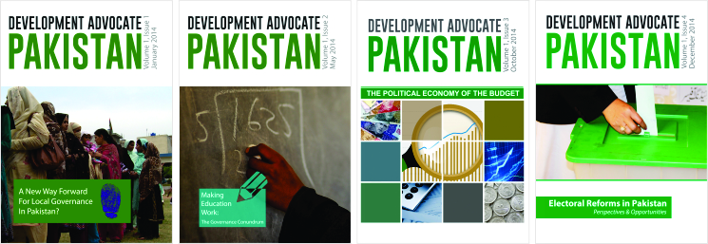

The first issue on “A new way forward for Local Governance in Pakistan,” investigated Local Governance issues in Pakistan and sought ways to improve the system. Several influential government representatives and policy specialists, such as Ms. Thusitha Pilapitiya and Mr. Ishtiaq Ahmad, contributed opinion pieces. The media coverage was in leading newspapers such as The Express Tribune and the Daily Times, among others.

The second issue on “Making Education Work: The Governance Conundrum,” discussed and offered recommendations in the areas of allocation and expenditure issues, the capacity issues of service providers, the political context of education, the impact of education expenditure and the quality of the current education system. Several key educationists, such as Dr. Faisal Bari and Mr. Mosahrraf Zaidi, offered valuable opinion pieces. The publication was in several leading newspapers such as Dawn and The Nation, among others.

The third issue on “The Political Economy of the Budget,” discussed, largely, three obstacles to improving transparency in the budget making process including weak citizen involvement, limited Parliamentary debate and unavailable or opaque information. Budget and policy specialists, such as Dr. Abid Suleri and Dr. Pervez Tahir, wrote opinion pieces for the issue. This issue was covered by leading media houses such as Business Recorder and the Associated Press of Pakistan, among others.
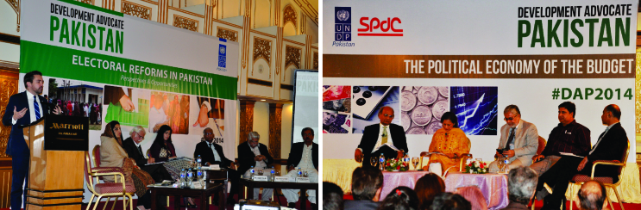

The fourth issue on ‘Electoral reforms in Pakistan: perspectives and opportunities” deliberated on issues of problem identification, gender gaps in voters, technology in elections, local government elections and implementation of electoral reforms were debated and discussed. The final issue of the year brought together eminent political party representatives for a panel discussion so as to create a lasting impact, especially at a time when electoral reforms in Pakistan were a heated debate. Thereby, the issue itself aimed at including opinions pieces pertaining to writers from diverse fields, such as Mr. Ambassador Lars-Gunnar Wigemark, Ambassador of the European Union to Pakistan, among others. The issue was characterized by a great print and electronic media presence, including coverage in leading media outlets such as Dawn and The Express Tribune, among others.

Overall Output Status (mark the output on the scale of 1 to 5 as per the following criteria):
Exemplary (5)  ***** | High (4)  **** |  | Satisfactory (3)  *** |  | Poor (2)  ** |  | Inadequate (1)  *
The project is expected to over-achieve targeted outputs and/or expected levels of quality, and there is evidence that outputs are contributing to targeted outcomes | The project is expected to over-achieve targeted outputs and/or expected levels of quality |  | The project is expected to achieve targeted outputs with expected levels of quality |  | The project is expected to partially achieve targeted outputs, with less than expected levels of quality |  | Project outputs will likely not be achieved and/or are not likely to be effective in supporting the achievement of targeted outcomes
Means of Verification
Overall DAP report
Media coverage
MPI consultations record.

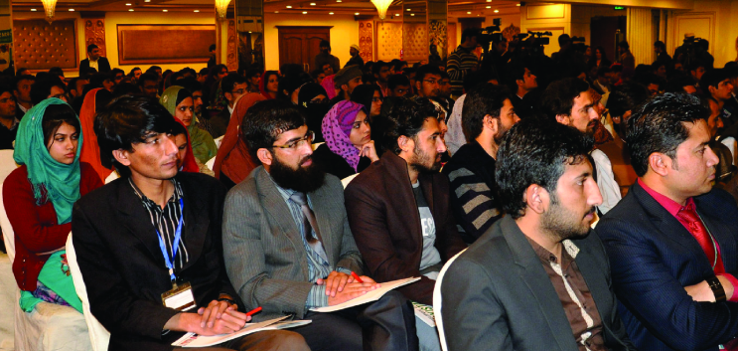

Project Output IV: Cross practice project development support provided to other units of UNDP

Indicator(s): - Mechanism established to facilitate cross-practice project development  - Extent to which the cross-units project(s) support have been effective |  | Baseline:  - No institutional mechanism for cross practice project development support available |  | Target(s):  - Support to the governance unit through an established mechanism for developing project with the planning commission of Pakistan  - Preparation of MDG Acceleration Framework |  | Achievement(s):
Description of output level results achieved in 2014:

Planning Commission Project: to support the roll out of Vision 2025 and 11th Five Year Plan.
Under PSP in 2014 human resources development support to the partnering Government Ministry i.e. Ministry of Planning, Development and Reforms was provided. The support included Vision 2025/ Institutional reforms in this regard; terms of reference were prepared for the project formulation mission, experts were mobilized from the UNDP regional center and consultations were organized.
Further, support was also provided towards drafting of the project strategy document. One of the key intervention of 2015 was preparation of multi-donor project with the Planning Commission of Pakistan in support to the roll out of Vision 2025 and 11th Five Year Plan. The project strategy document was finalized with Planning Commission on cost sharing basis. The key areas of the intervention include Governance Reforms introduction of Results Based Matrix at the national/ provincial development plans.
Another intervention for which advocacy and networking was done throughout 2014 was the project proposal on Garments Industry. The USAID funding is approved and a MoU is signed. The project will be implemented by Crisis Prevention and Recovery Unit.
Millennium Development Goals Acceleration Framework (MAF):
To build on the inputs of the national consultation and further localize the MAF action plans, from Jan – June 2014 multi-stakeholder workshops were held in all provinces to gather province specific inputs. The workshops gathered key representatives focusing on Net Primary Enrolment at the provincial level from government institutions, UN agencies, multilateral and bilateral partners, private sector, NGOs and civil society.

To ensure Government buy-in bilateral one–to-one meetings/ group discussions were held in each of the provincial capitals between the 14th of September and the 3rd of October. These detailed meetings were held in each of the provinces to finalize the draft Action Plans and ensure their alignment with provincial education sector strategies and plans. These meetings involved focused discussions with provincial education and planning and development departments on their ongoing interventions and bottlenecks to their implementation as well as one to one exchanges with donors, civil society representatives and private sector organizations to identify and build on cross-sectoral solutions. As mentioned above, the output of these meetings were endorsed MAF Action Plans.
Considering findings of the national and provincial consultations, provincial action plans, education plans, discussions/consultations to validate and add/delete the proposed priority interventions, the finalized bottlenecks, high-impact and preliminary feasible solutions – draft report was made and feedback gathered. Finally, considering the provincial MAF Action Plan’s - a report was finalized towards end of the year 2014 which was presented at the Executive Board meeting.

Overall Output Status (mark the output on the scale of 1 to 5 as per the following criteria):
Exemplary (5)  ***** | High (4)  **** |  | Satisfactory (3)  *** |  | Poor (2)  ** |  | Inadequate (1)  *
The project is expected to over-achieve targeted outputs and/or expected levels of quality, and there is evidence that outputs are contributing to targeted outcomes | The project is expected to over-achieve targeted outputs and/or expected levels of quality |  | The project is expected to achieve targeted outputs with expected levels of quality |  | The project is expected to partially achieve targeted outputs, with less than expected levels of quality |  | Project outputs will likely not be achieved and/or are not likely to be effective in supporting the achievement of targeted outcomes
Means of Verification
MAF report
MAF national consultations records (attendance etc..)
Planning Commission Project Document submitted.

- Lessons Learnt

- There are low levels of linkages across projects boards. With other projects of similar nature; even in the same field or sector and where projects operate in the same territory. There is a need for UNDP Pakistan to address horizontal communication problems within i.e. with other UNDP units and with agencies responsible for inter-country programs as well. This lesson was learnt earlier during the project therefore owing to the learning two development advocate issues were focused on governance sector i.e. local governance reforms and elections reforms and MDG workshop was managed consulting provincial MDG working groups with elections project team.
- Continuous engagement with Government counterparts to ascertain the Government priorities is essential. A clear statement of the broader development problem to be addressed. One of the main output of the project work plan is to develop a project with Planning Commission on governments vision 2025, the proposal was developed after thorough consultations with government on post 2015 development agenda and vision 2025.
- To activate the Project Board; very few projects are found to involve stakeholders and partners in decision-making from preparation through design to implementation and monitoring. It was decided that this project will involve stakeholders in decision making – this hasn’t happened. 2014 was the first year of implementation, the project board activation is a priority of 2015, it was felt that the board will give the strategic push which is required.
- One of the key lessons leant under monitoring and implementation: was that the work done by DPU has limited information/data about baseline, milestones and performance indicators. Most of the interventions are at policy level/ policy papers/ conducting study/ working papers/ exchange of knowledge – the effectiveness is hard to measure. As a consequence, it is extremely difficulty to monitor project performance both in qualitative and quantitative aspects. Therefore a mid-term review linking output level achievements with the outcome is recommended.
- National Human Development Report: in 2014, the team, the structure of scope and concept of the key deliverable in the National Human Development Report focusing was established. The implementation through focus group discussions, youth survey, media and advocacy in next 12 months is planned, this needs administrative and operational support. A lesson learnt is to strengthen the capacity of NHDR staff under this activity making, these technical experts, more operationally sound and aware of UNDP policies and procedures.

- The way forward/ key Priorities FOR 2015

There are three main priorities in 2015:

- National Human Development Report 2015 (launch and dissemination)
- Through consultations with stakeholders identification of gaps in development agenda. Using the gaps research to be undertaken and knowledge generated /disseminated on these selected development themes.
- Using advocacy and capacity building tools (including exchange of learning) to encourage public financial expenditure towards key development areas in 2015.

Annex: AWP based Reporting Matrix

EXPECTED OUTPUTS  And baseline, associated indicators and annual targets | PLANNED ACTIVITIES (as per AWP) | Activity Status  Completed, Ongoing, Delayed, Cancelled | AWP Budget ($) | Expenditure ($) | % Delivery
Project Output 1  Indicators:  Baseline:  Targets: | 1. Activity
 | 2. Activity
 | 3. Activity
 | 4. Activity
Project Output 2  Indicators:  Baseline:  Targets: | 1. Activity
 | 2. Activity
 | 3. Activity
 | 4. Activity
Project Output 3  Indicators:  Baseline:  Targets: | 1. Activity
 | 2. Activity
 | 3. Activity
 | 4. Activity
Project Output 4  Indicators:  Baseline:  Targets: | 1. Activity
 | 2. Activity
 | 3. Activity
 | 4. Activity
TOTAL

Outcomes describe the intended changes in development conditions that result from the interventions of governments and other stakeholders, including international development agencies such as UNDP. They are medium-term development results created through the delivery of outputs and the contributions of various partners and non-partners. Outcomes provide a clear vision of what has changed or will change globally or in a particular region, country or community within a period of time. They normally relate to changes in institutional performance or behavior among individuals or groups. Outcomes cannot normally be achieved by only one agency and are not under the direct control of a project manager.
Outputs are short-term development results produced by project and non-project activities. They must be achieved with the resources provided and within the time-frame specified (usually less than five years).

